**Model Development Phase Template**

|  |  |
| --- | --- |
| Date | 23 June 2025 |
| Team | **AS PS VS VV** |
| Project Title | Unemployed Insurance Beneficiary Forecasting |
| Maximum Marks | 10 Marks |

**Initial Model Training Code, Model Validation and Evaluation Report**

The initial model training code will be showcased in the future through a screenshot. The model validation and evaluation report will include a summary and training and validation performance metrics for multiple models, presented through respective screenshots.

**Initial Model Training Code (5 marks):**

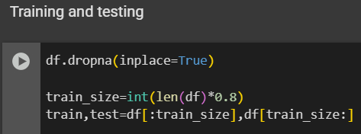

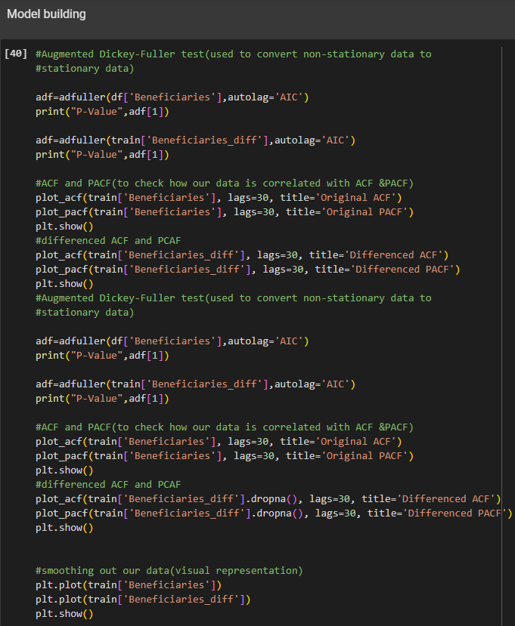

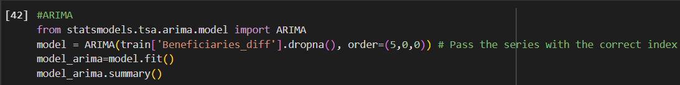 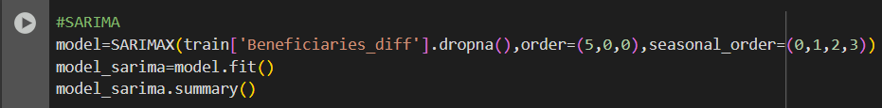 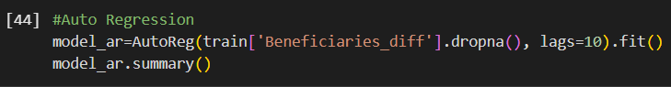 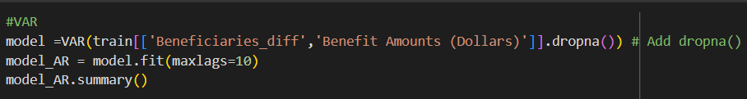 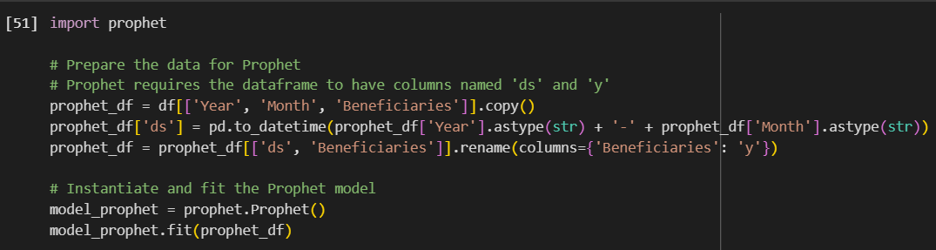

**Model Validation and Evaluation Report (5 marks):**

|  |  |  |
| --- | --- | --- |
| **Model** | **Summary** | **Training and Validation Performance Metrics (MSE,MAE,R2 score)** |
| ARIMA |  |  |
| SARIMA |  | R2-score: NA |
| AutoReg |  | R2-score: NA |
| VAR |  | NA |
| Prophet |  |  |